*COS 80001 – Cloud Engineering*

*Assignment 1b*

Assignment 1b: Photo Album Deployment on AWS Infrastructure  
Student Name: Arun Ragavendhar Arunachalam Palaniyappan   
Student ID: 104837257  
Tutorial Time: Friday – 04:30 PM to 06:30 PM  
Course: COS80001 - Cloud Engineering  
Assignment: 1B - Photo Album Web Application Deployment

# 1.Infrastrucutre Setup

This report explains how a simple photo album website was built and deployed on AWS, following the assignment instructions. The main goal was to create a secure cloud setup where users can upload and view photos. These photos are stored in an S3 bucket, and their metadata (like title, description, and keywords,) is saved in a MySQL database running on RDS. The project includes setting up a secure network with VPC, EC2 instances, database access, and applying proper security controls using security groups and network ACLs.

## 1.1 VPC, Subnets and Routing Tables setup

The first step was to create a custom VPC **ARagavendharVPC** in the us-east-1 region. This VPC was built and set up with CIDR IP 10.0.0.0/16

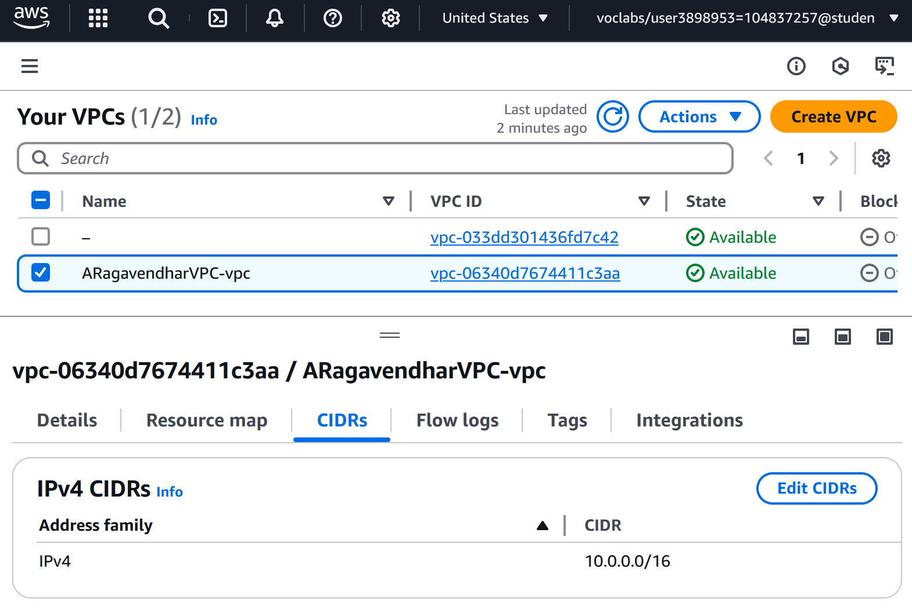

Figure 1: The Custom VPC

The next step was to create two public subnets (for web server access and internet connectivity) one in each availability zone with CIDR – 10.0.1.0/24 for Availability Zone A and 10.0.2.0/24 for Availability Zone B. Then two private subnets (for database and test instance, kept secure from the internet) were created with CIDR – 10.0.3.0/24 for Availability Zone A and 10.0.4.0/24 for Availability Zone B .

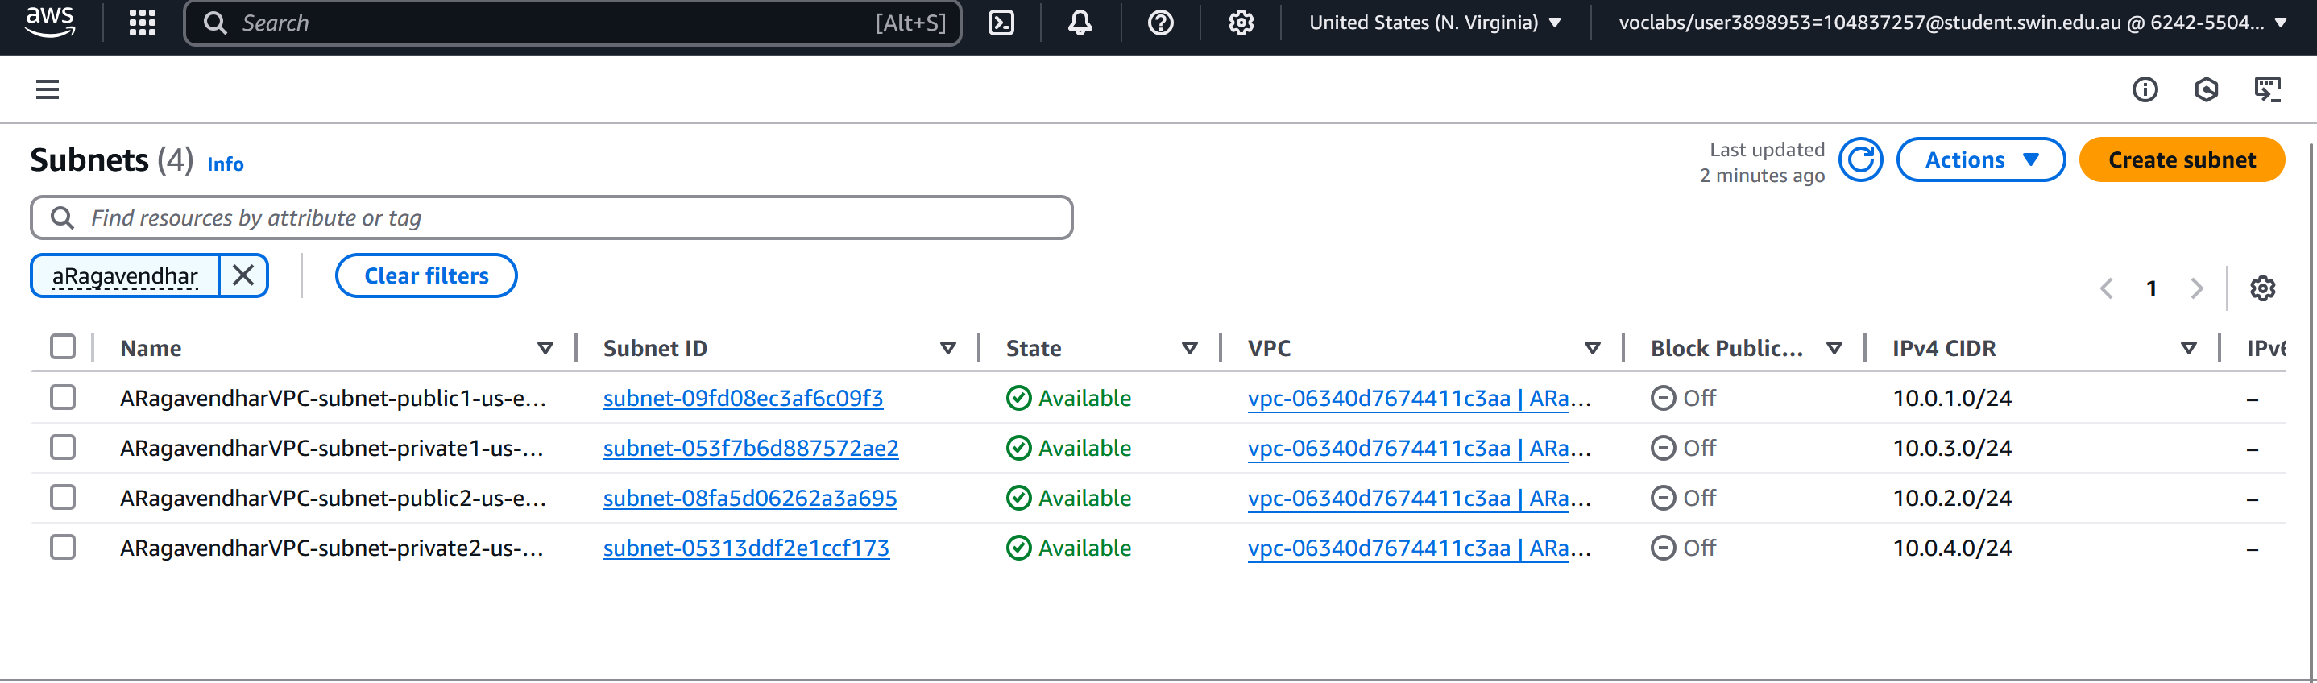

Figure 2: The Subnets

A route table was created for the public subnets and linked to an Internet Gateway, which allowed internet access to the web server.

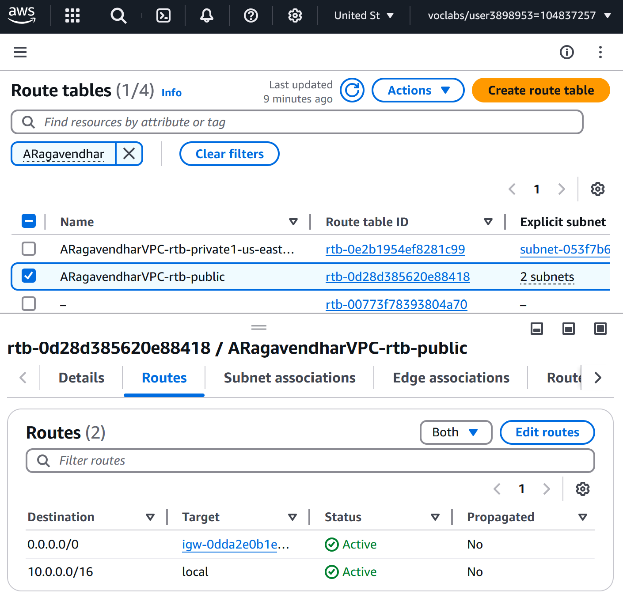 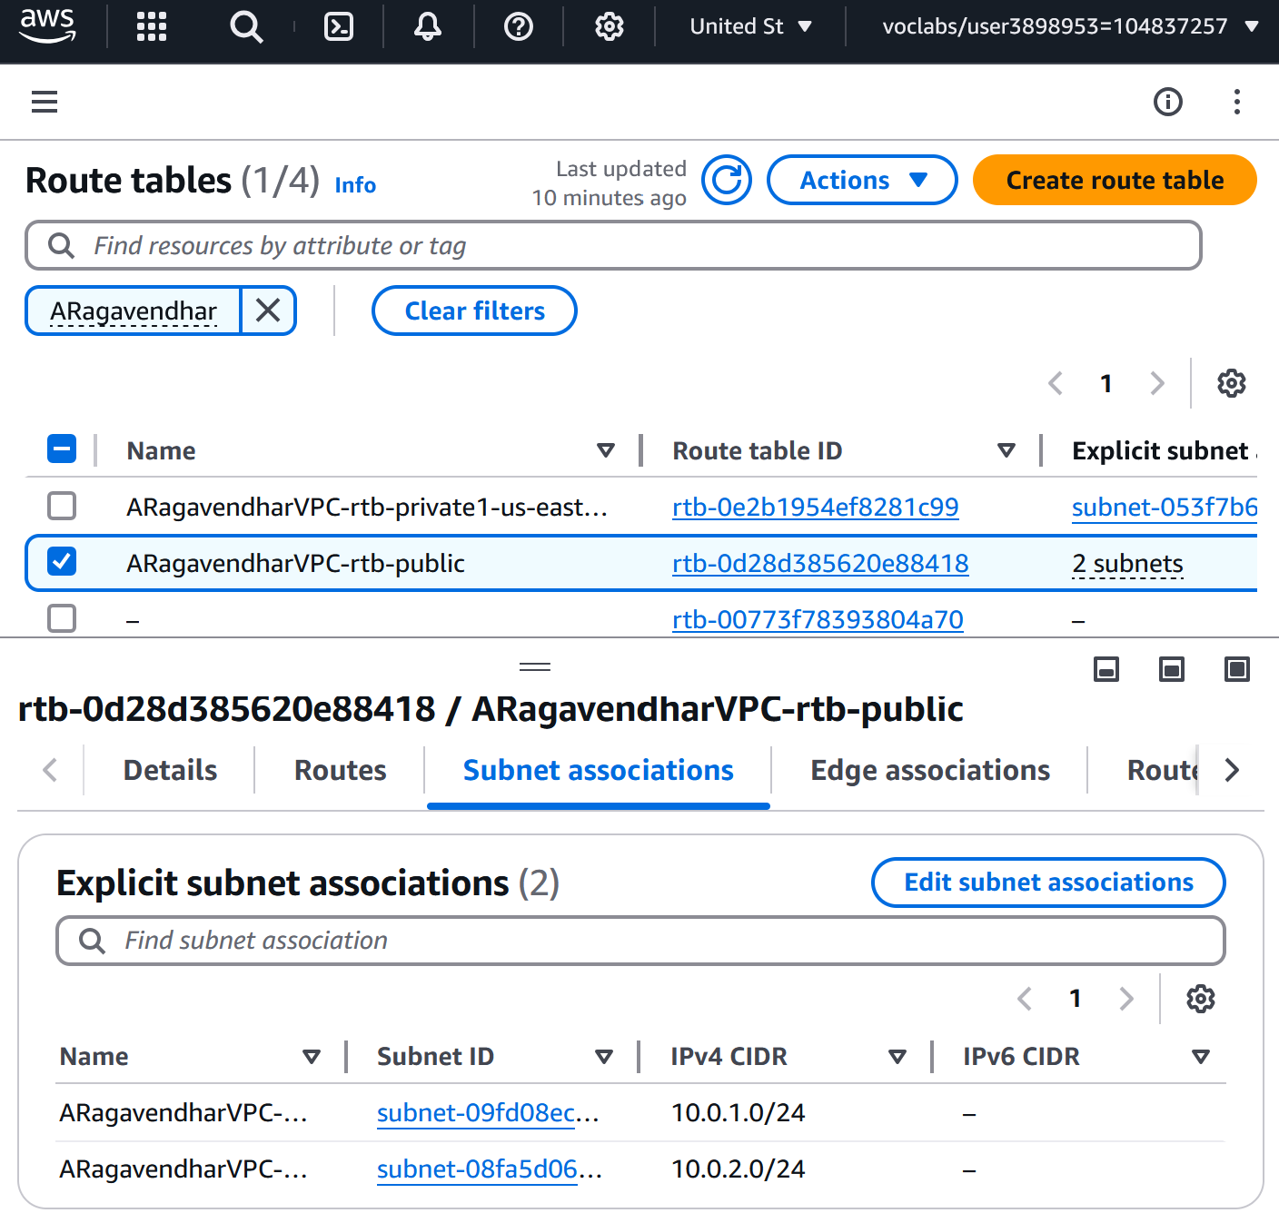

Figure 3: The public route table routes Figure 4: The public route table’s subnet associations

## 1.2 Security Groups Creation

Three security groups were set up:

* WebServerSG: Allowed HTTP (port 80) and SSH (port 22) from anywhere, and allowed ICMP (ping) from the Test instance.

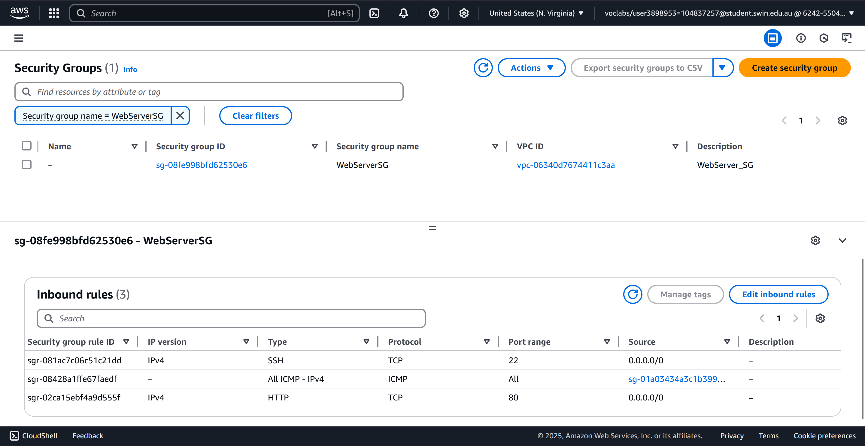

Figure 5: The inbound rules for the WebServerSG

* DBServerSG: Allowed MySQL (port 3306) access only from the web server.

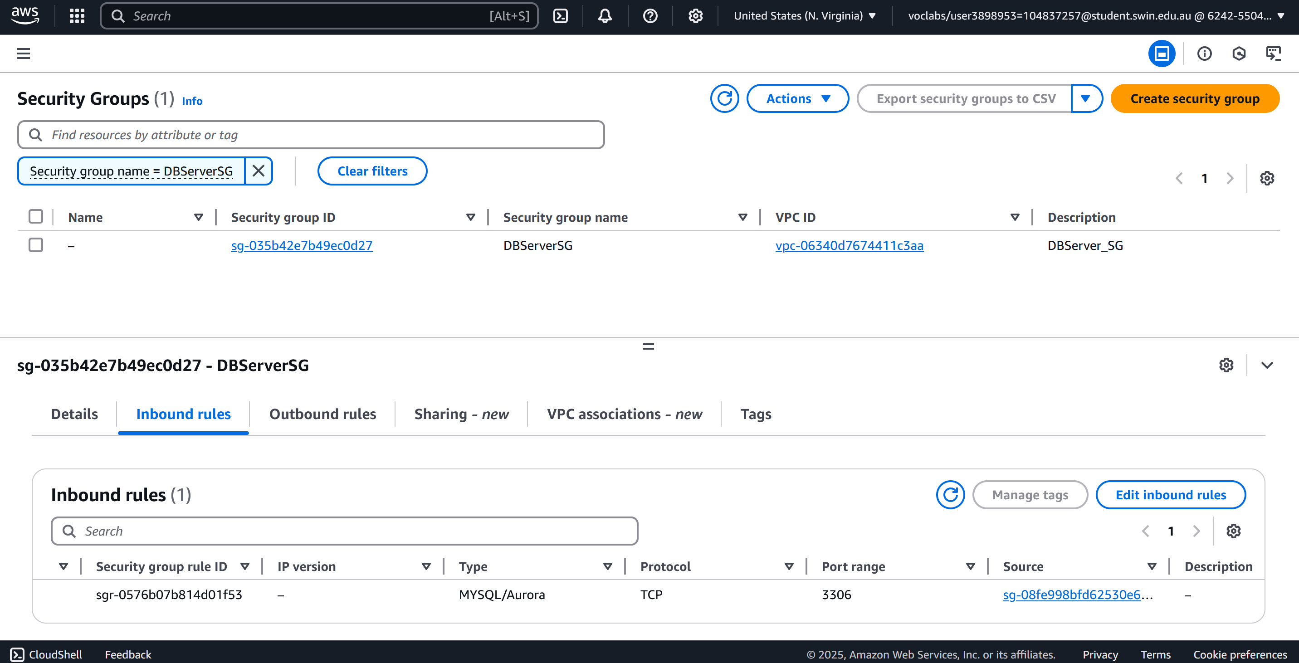

Figure 6: The inbound rules for the DBServerSG

* TestInstanceSG: Allowed all traffic, used only for testing internal access.

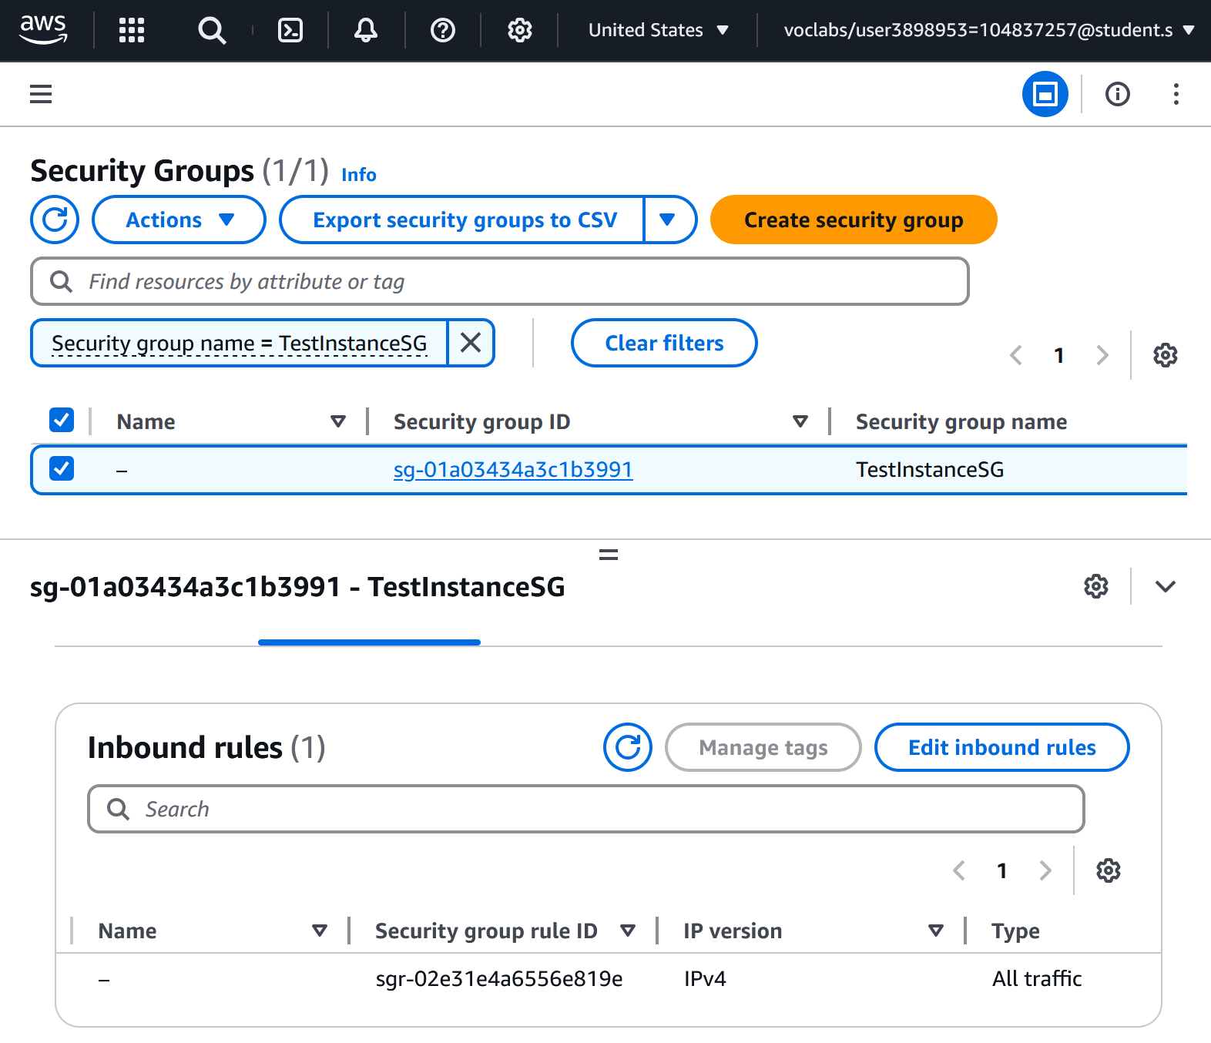

Figure 7: The inbound rules for the TestInstanceSG

## 1.3. Creating the EC2 Virtual Machines

Two EC2 instances were created:

Web Server / Bastion Host (in Public Subnet 2):

* Amazon Linux 2023 AMI, t2.micro instance
* Apache and PHP installed using a startup script
* Hosted the photo album application
* Assigned an Elastic IP for a fixed web address

This instance also worked as a bastion host to connect securely to the private test instance.

Web server ec2 instance

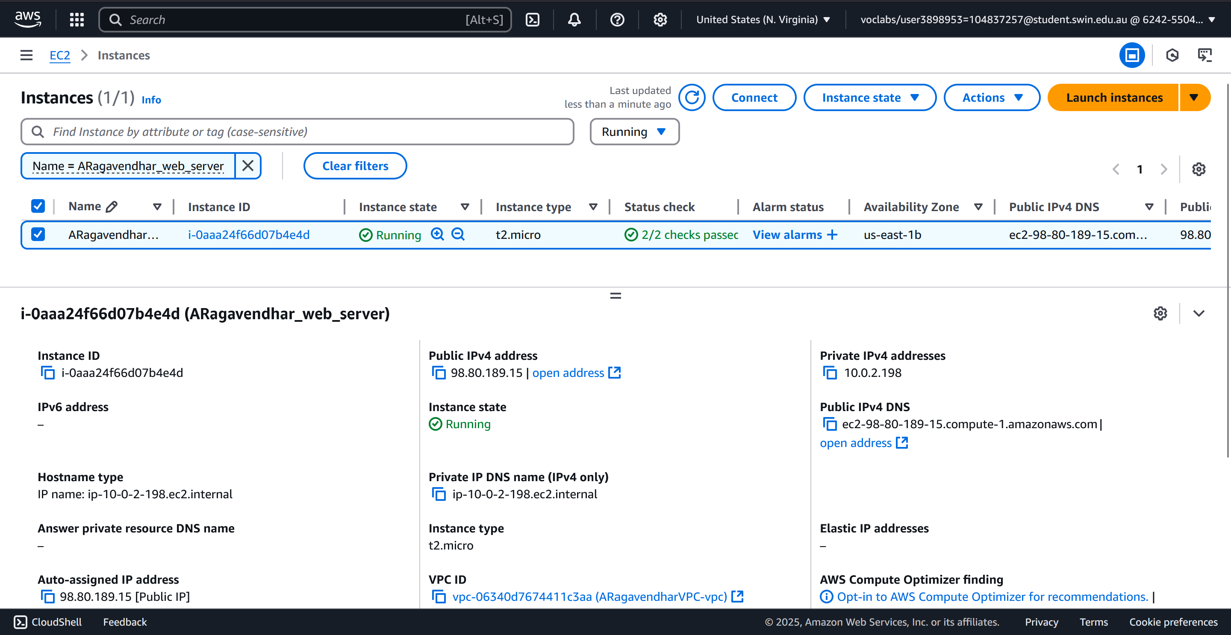

Figure 8: The web server instance on public subnet 2

Elastic Ip

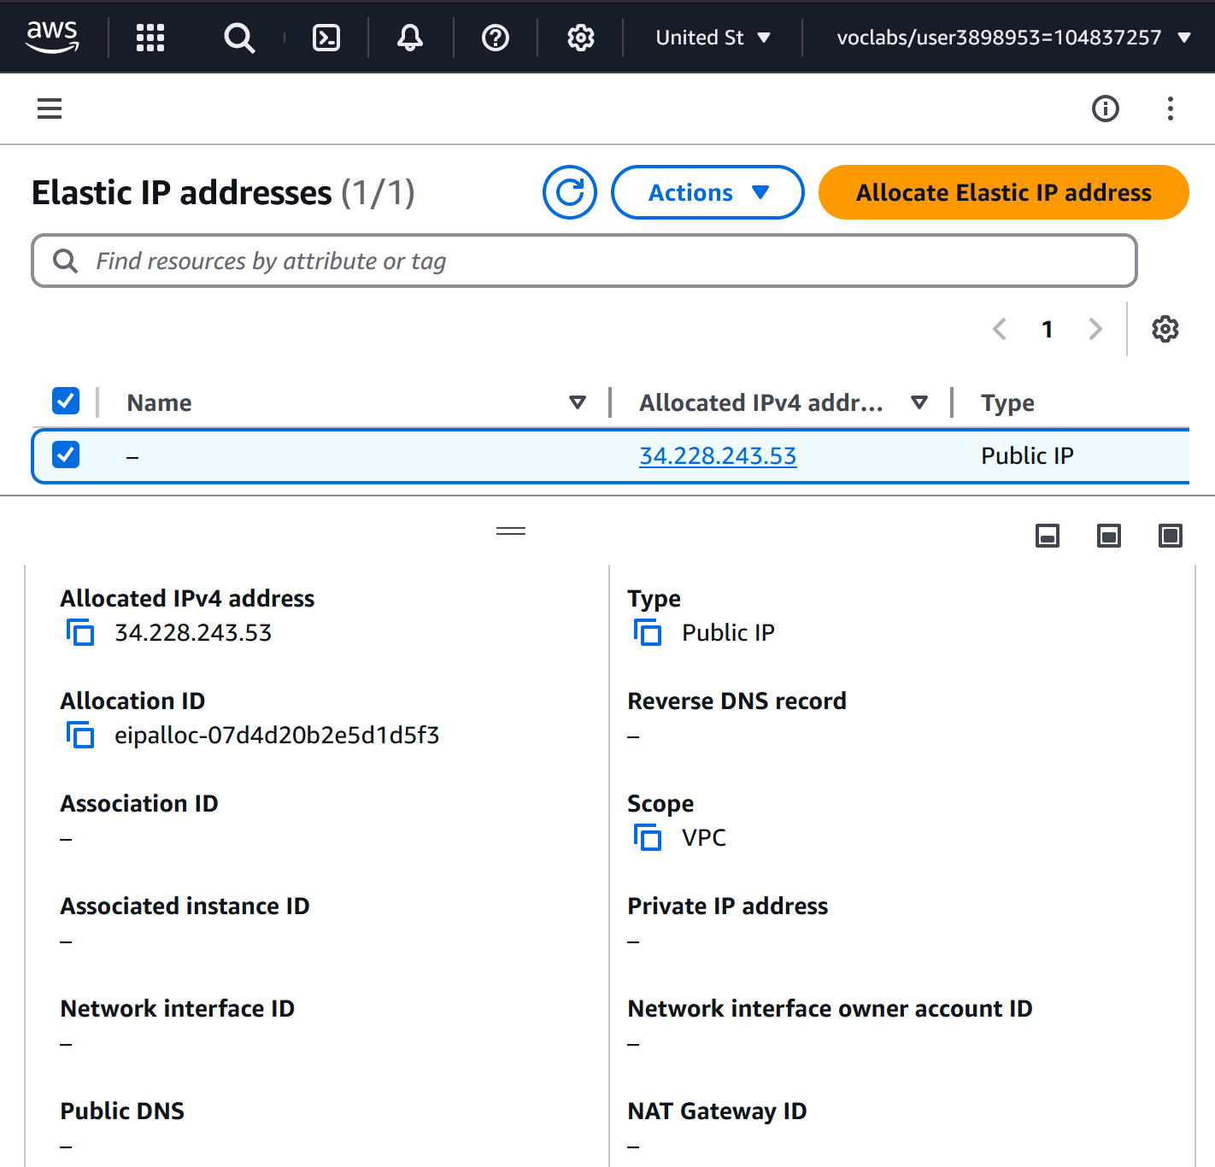

Figure 9: Elastic IP address created

Elastic Ip Assigned to Web server

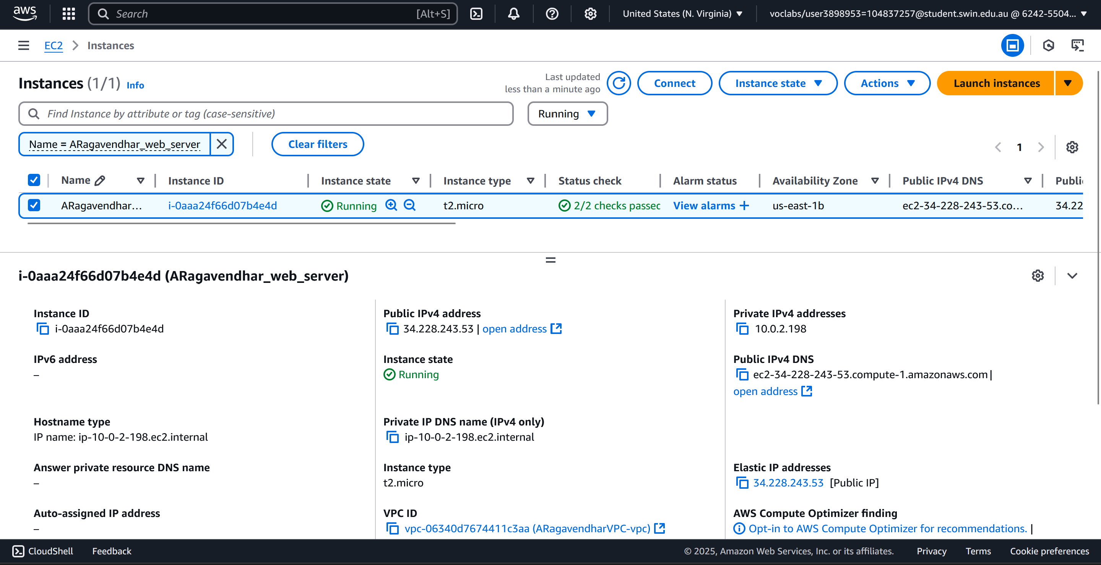

Figure 10: Elastic IP address associated with the web server Instance

Test Instance (in Private Subnet 2):

* Used to test internal connectivity
* SSH connection was made through the bastion host
* Verified connectivity using ping to the web server

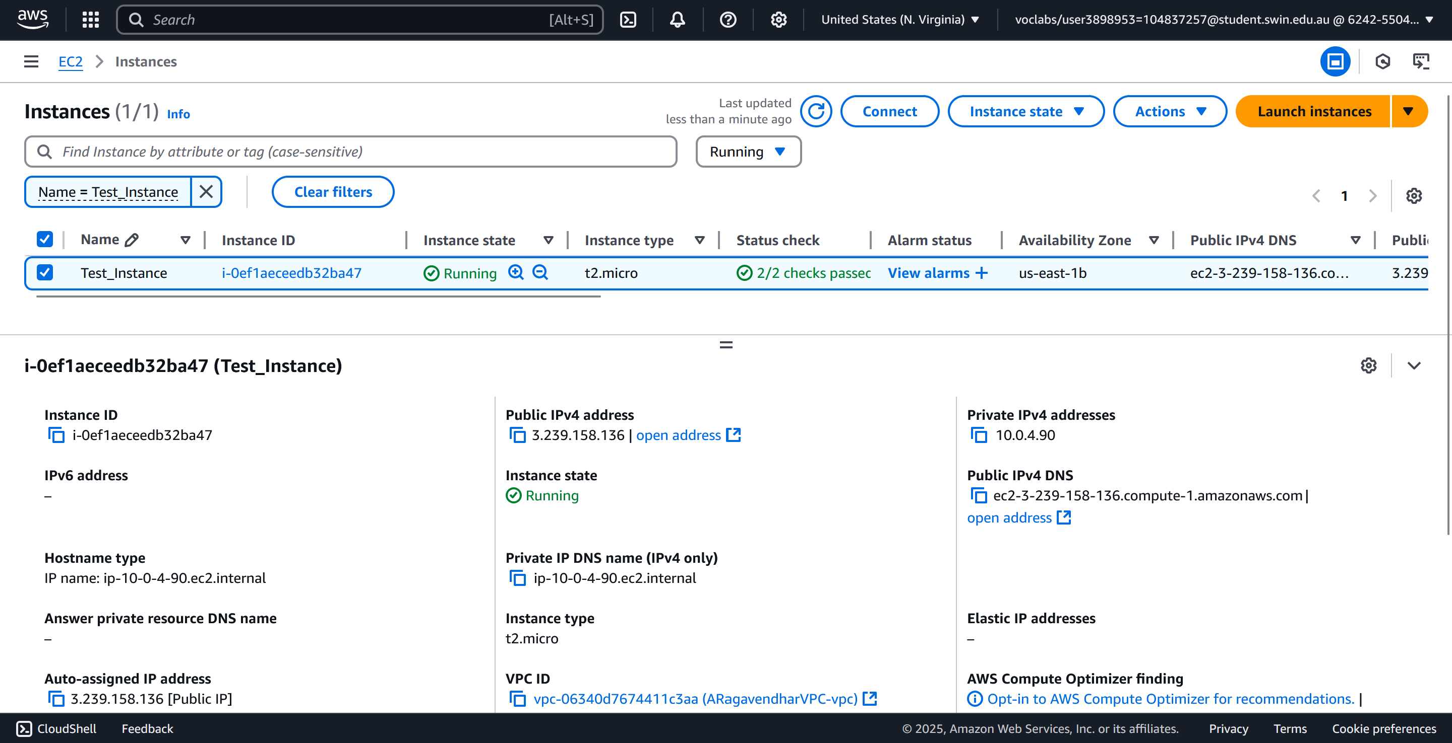

Figure 11: The private Test_Instance in private subnet2

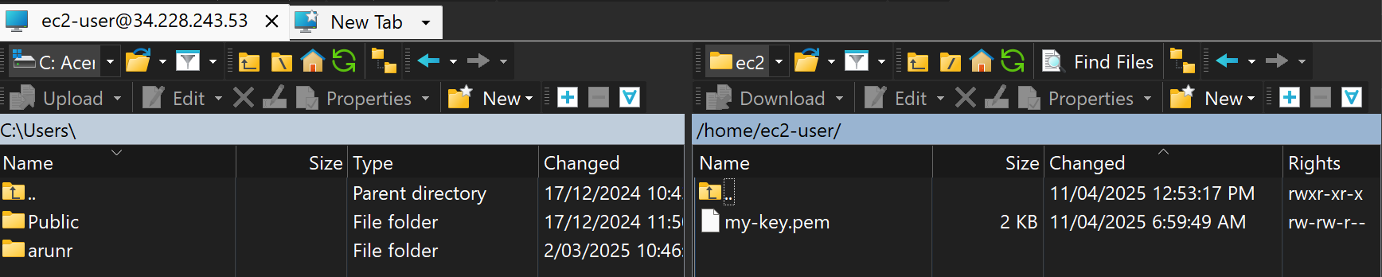

Figure 11: The private key file copied to the public ec2 instance

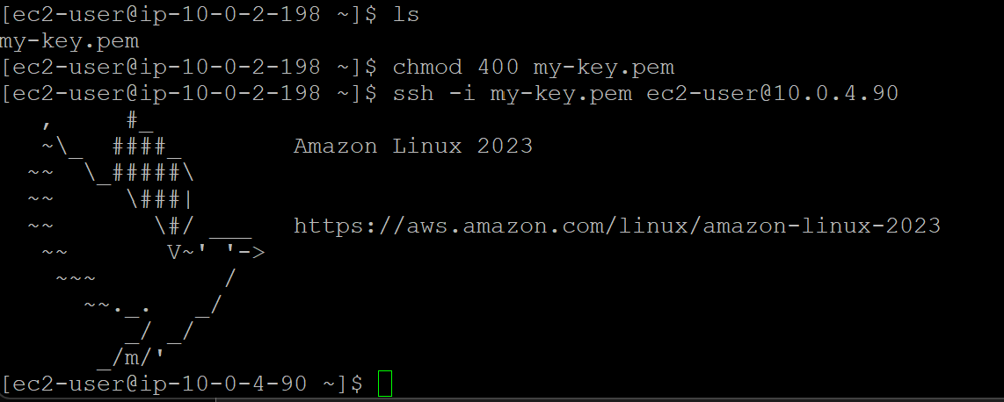

Figure 12: SSH login into the Private Test instance from the bastion web server

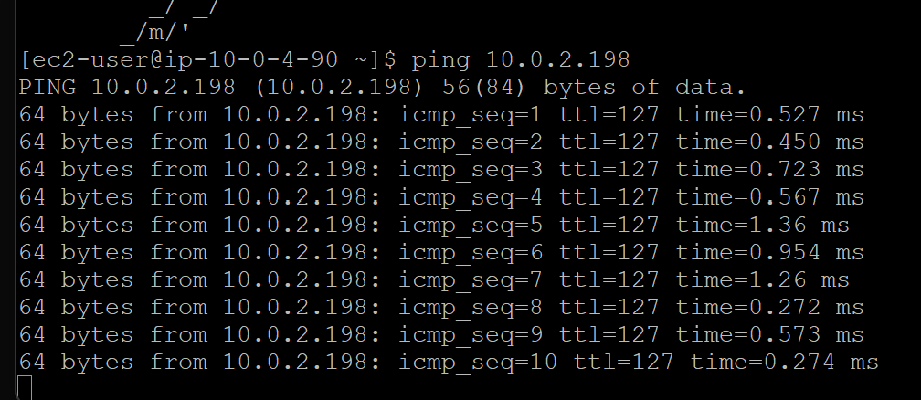

Figure 12: Successful ICMP ping from Test_Instance to the public web server

## 1.4. RDS Database Instance Setup

An Amazon RDS instance was created in one of the private subnets:

* MySQL version 8.0.39, free tier template
* Public access turned off for security
* Connected only to the WebServerSG security group

A MySQL database was created with a table called photos. This table had the following columns:

* title: to store photo titles
* description: short description of the image
* creation_date: when the photo was created
* keywords: tags or topics linked to the photo
* s3_reference: the direct S3 URL of the image

To manage this database, phpMyAdmin was installed on the web server. This allowed me to log in through a browser and add or edit database entries easily.

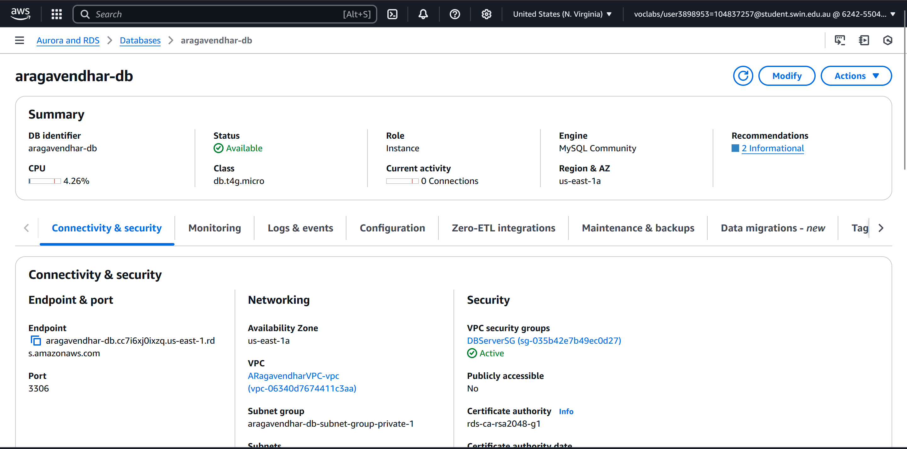

## 1.5 Setting Up Network ACL for public subnet 2

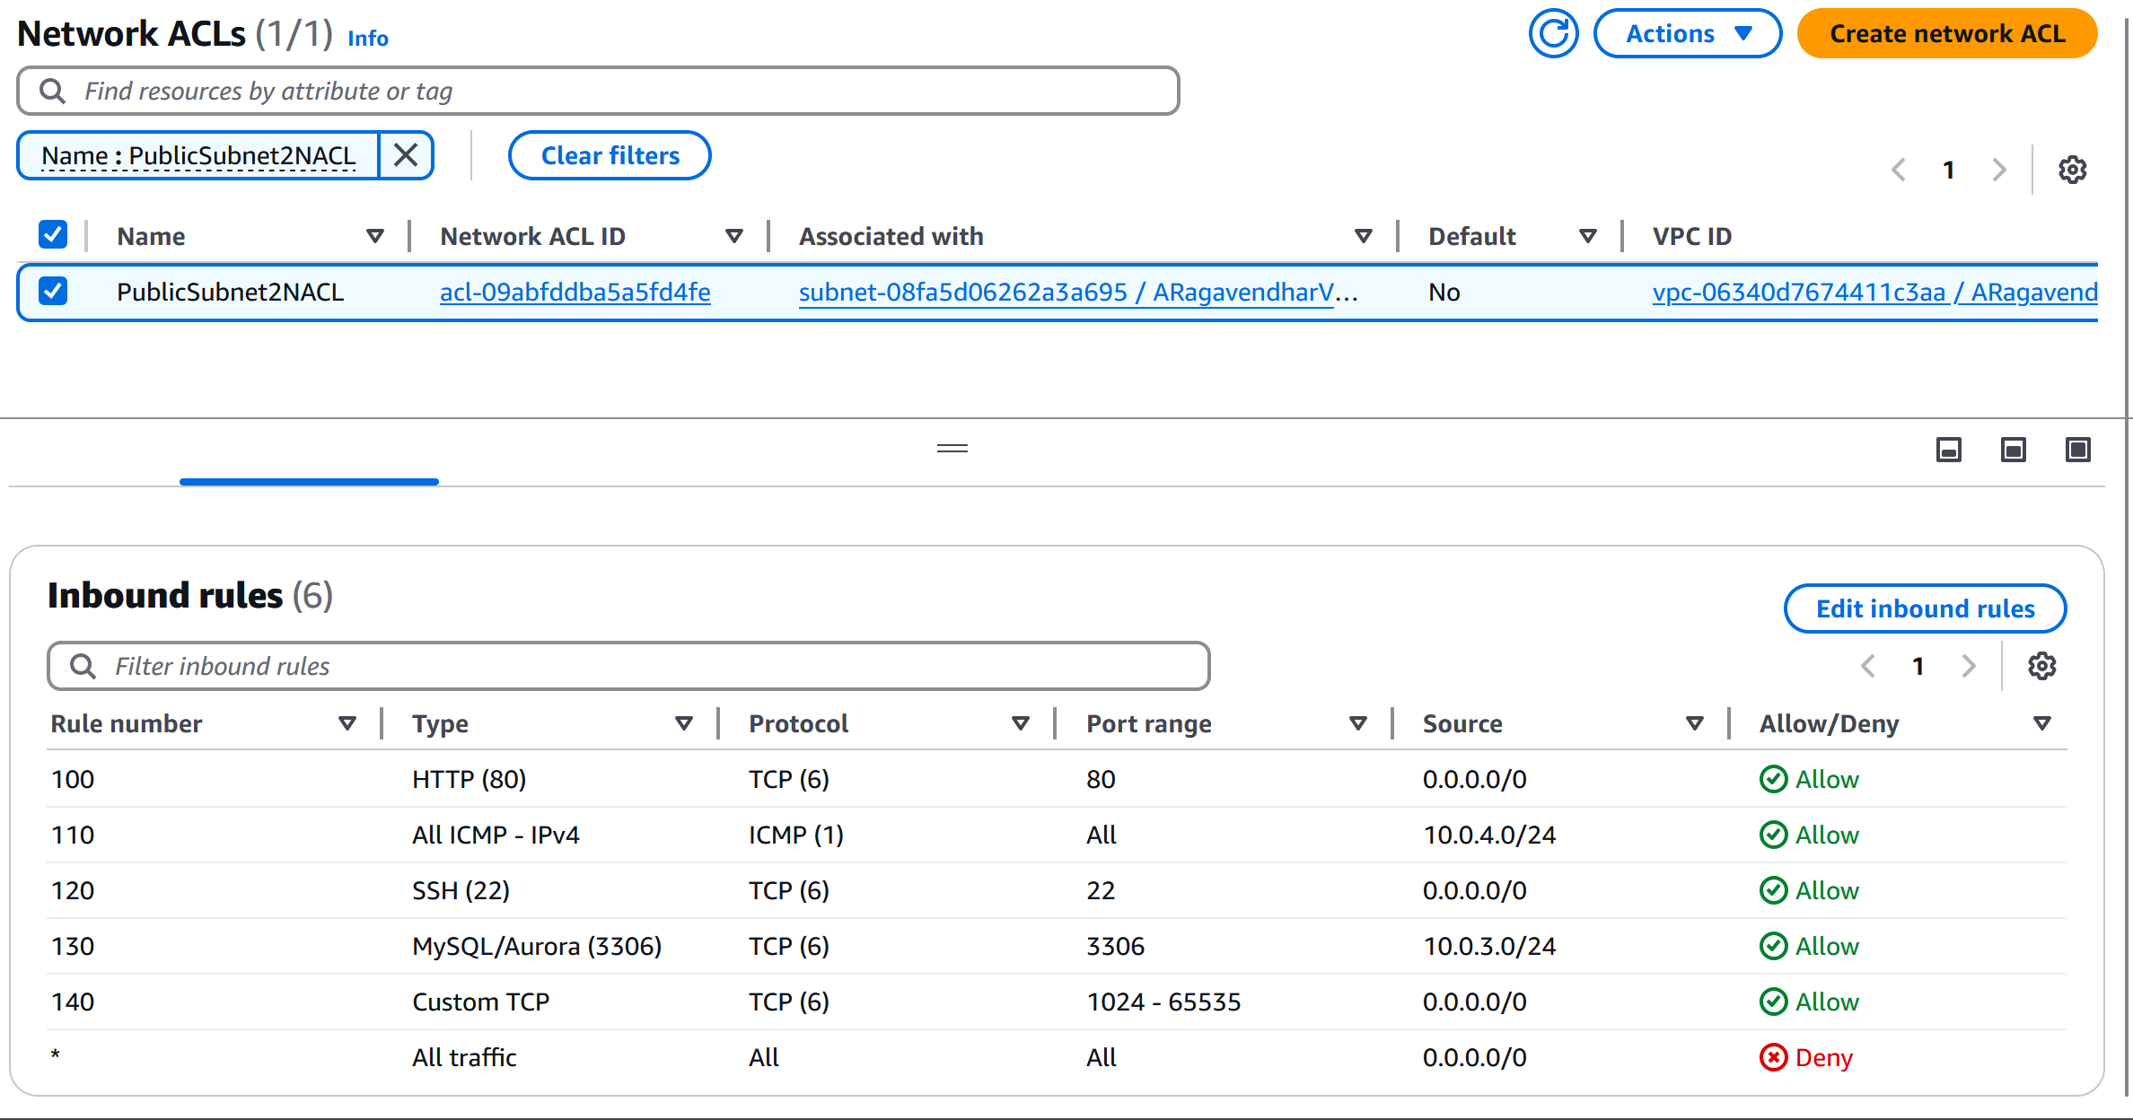

Figure:11 Inbound Rules for the NACL

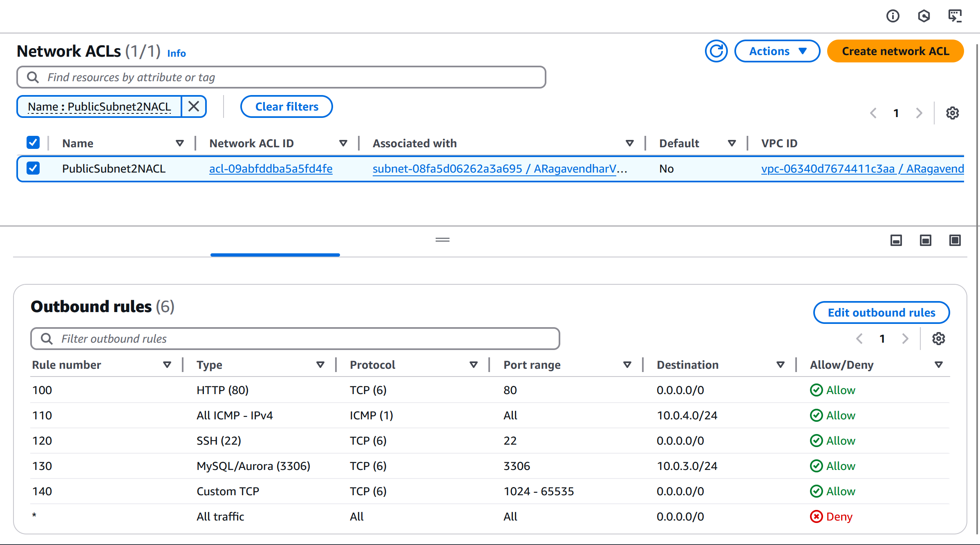

Figure:12 Outbound Rules for the NACL

# 2. Photo Album Application Setup

## 2.1 Photo storage using S3 bucket

A new S3 bucket named aragavendhar-photo-album was set up to store image files. Photos were uploaded manually. To make sure they could be accessed from the web, a bucket policy was applied that made all files publicly readable:

{

"Version": "2012-10-17",

"Statement": [

{

"Sid": "PublicReadGetObject",

"Effect": "Allow",

"Principal": "*",

"Action": "s3:GetObject",

"Resource": "arn:aws:s3:::aragavendhar-photo-album/*"

}

]

}

This avoided the need to set public permissions one-by-one for each file.

Network ACL:

A Network ACL named PublicSubnet2NACL was created and linked to the subnet hosting the web server. The rules allowed:

* SSH access from anywhere
* ICMP (ping) from the subnet of the Test instance
* HTTP and HTTPS access for public web access

These rules followed the principle of least privilege by blocking unnecessary traffic.

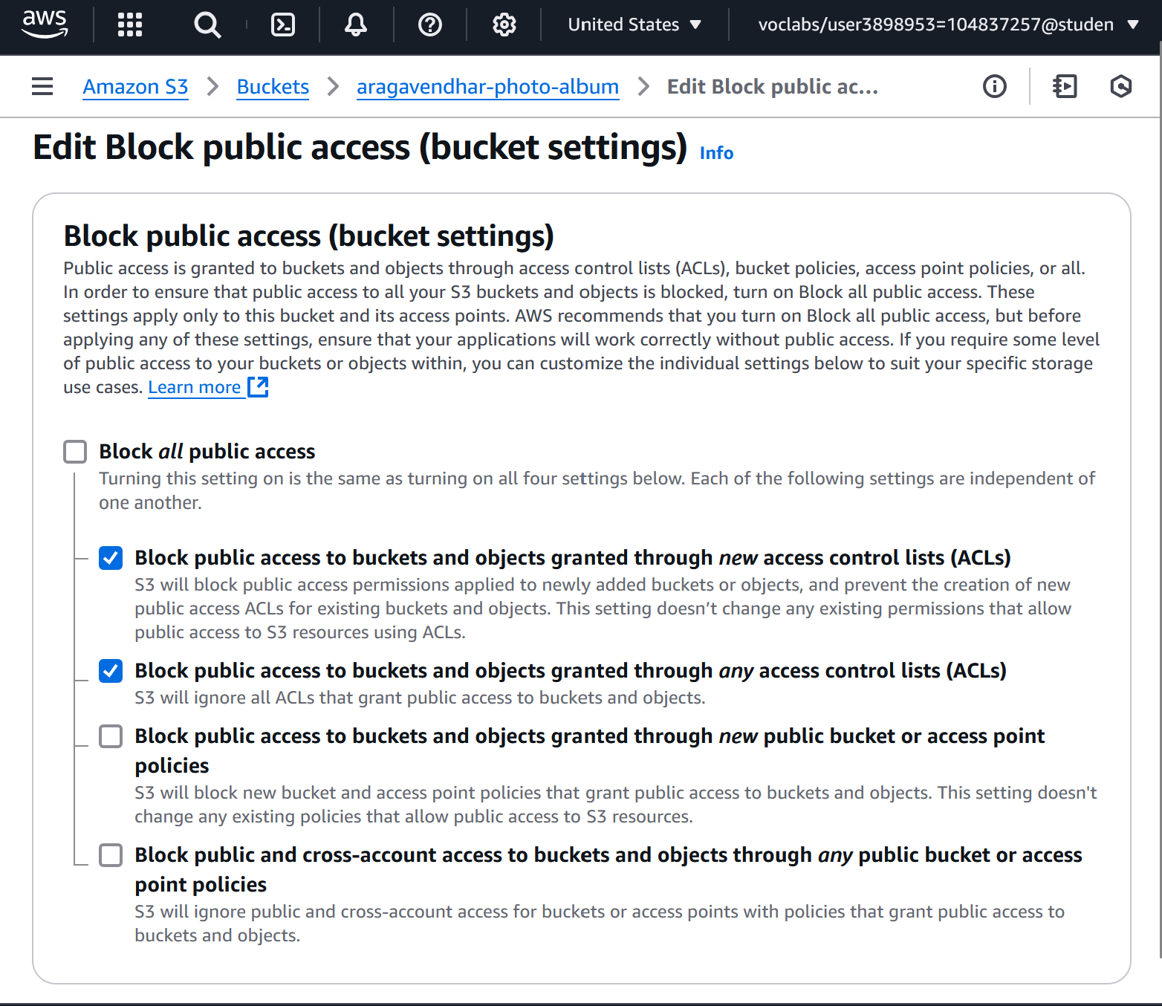

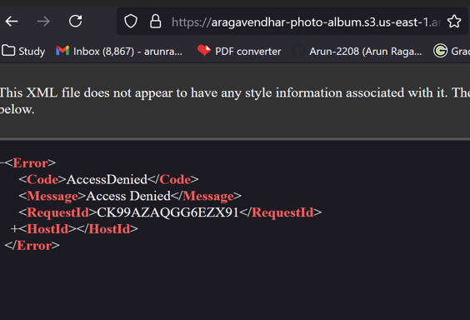 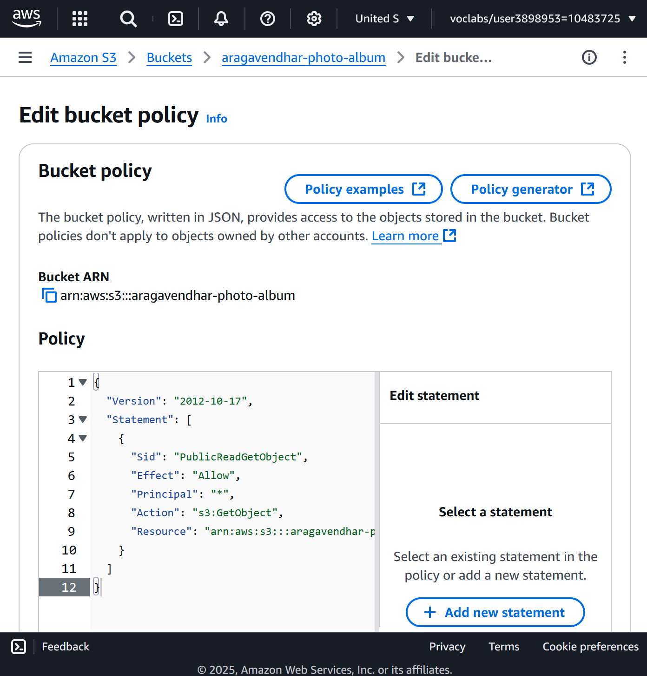

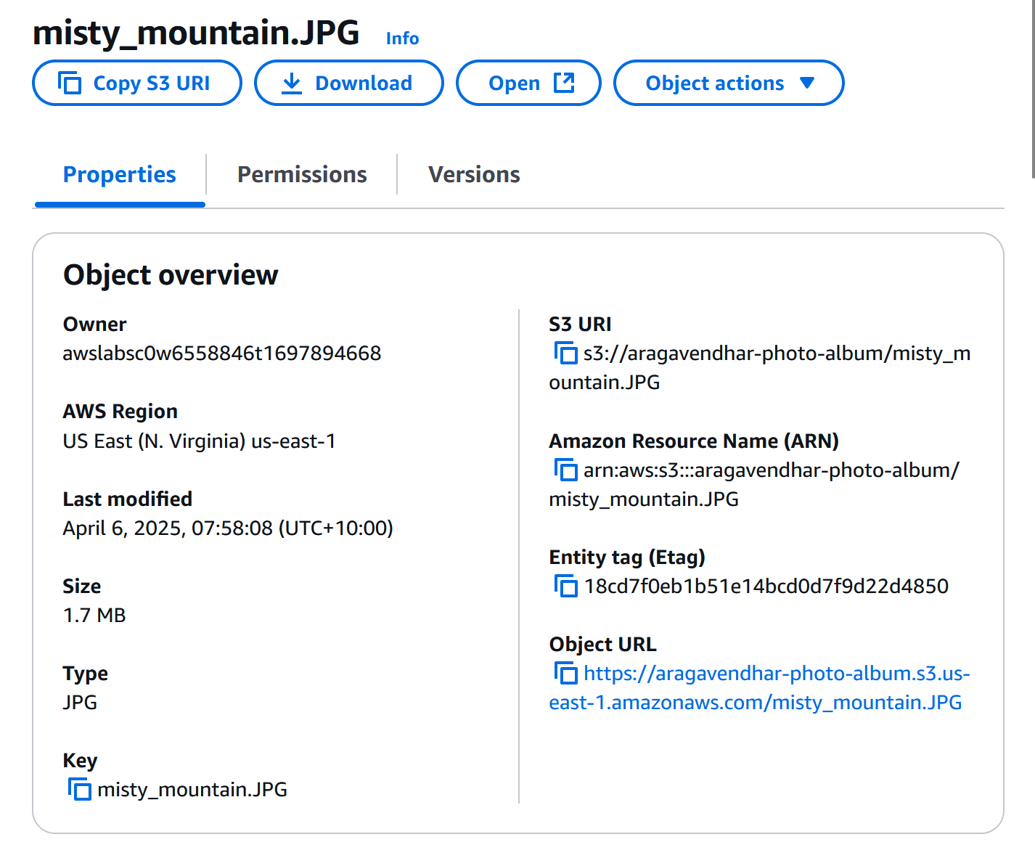 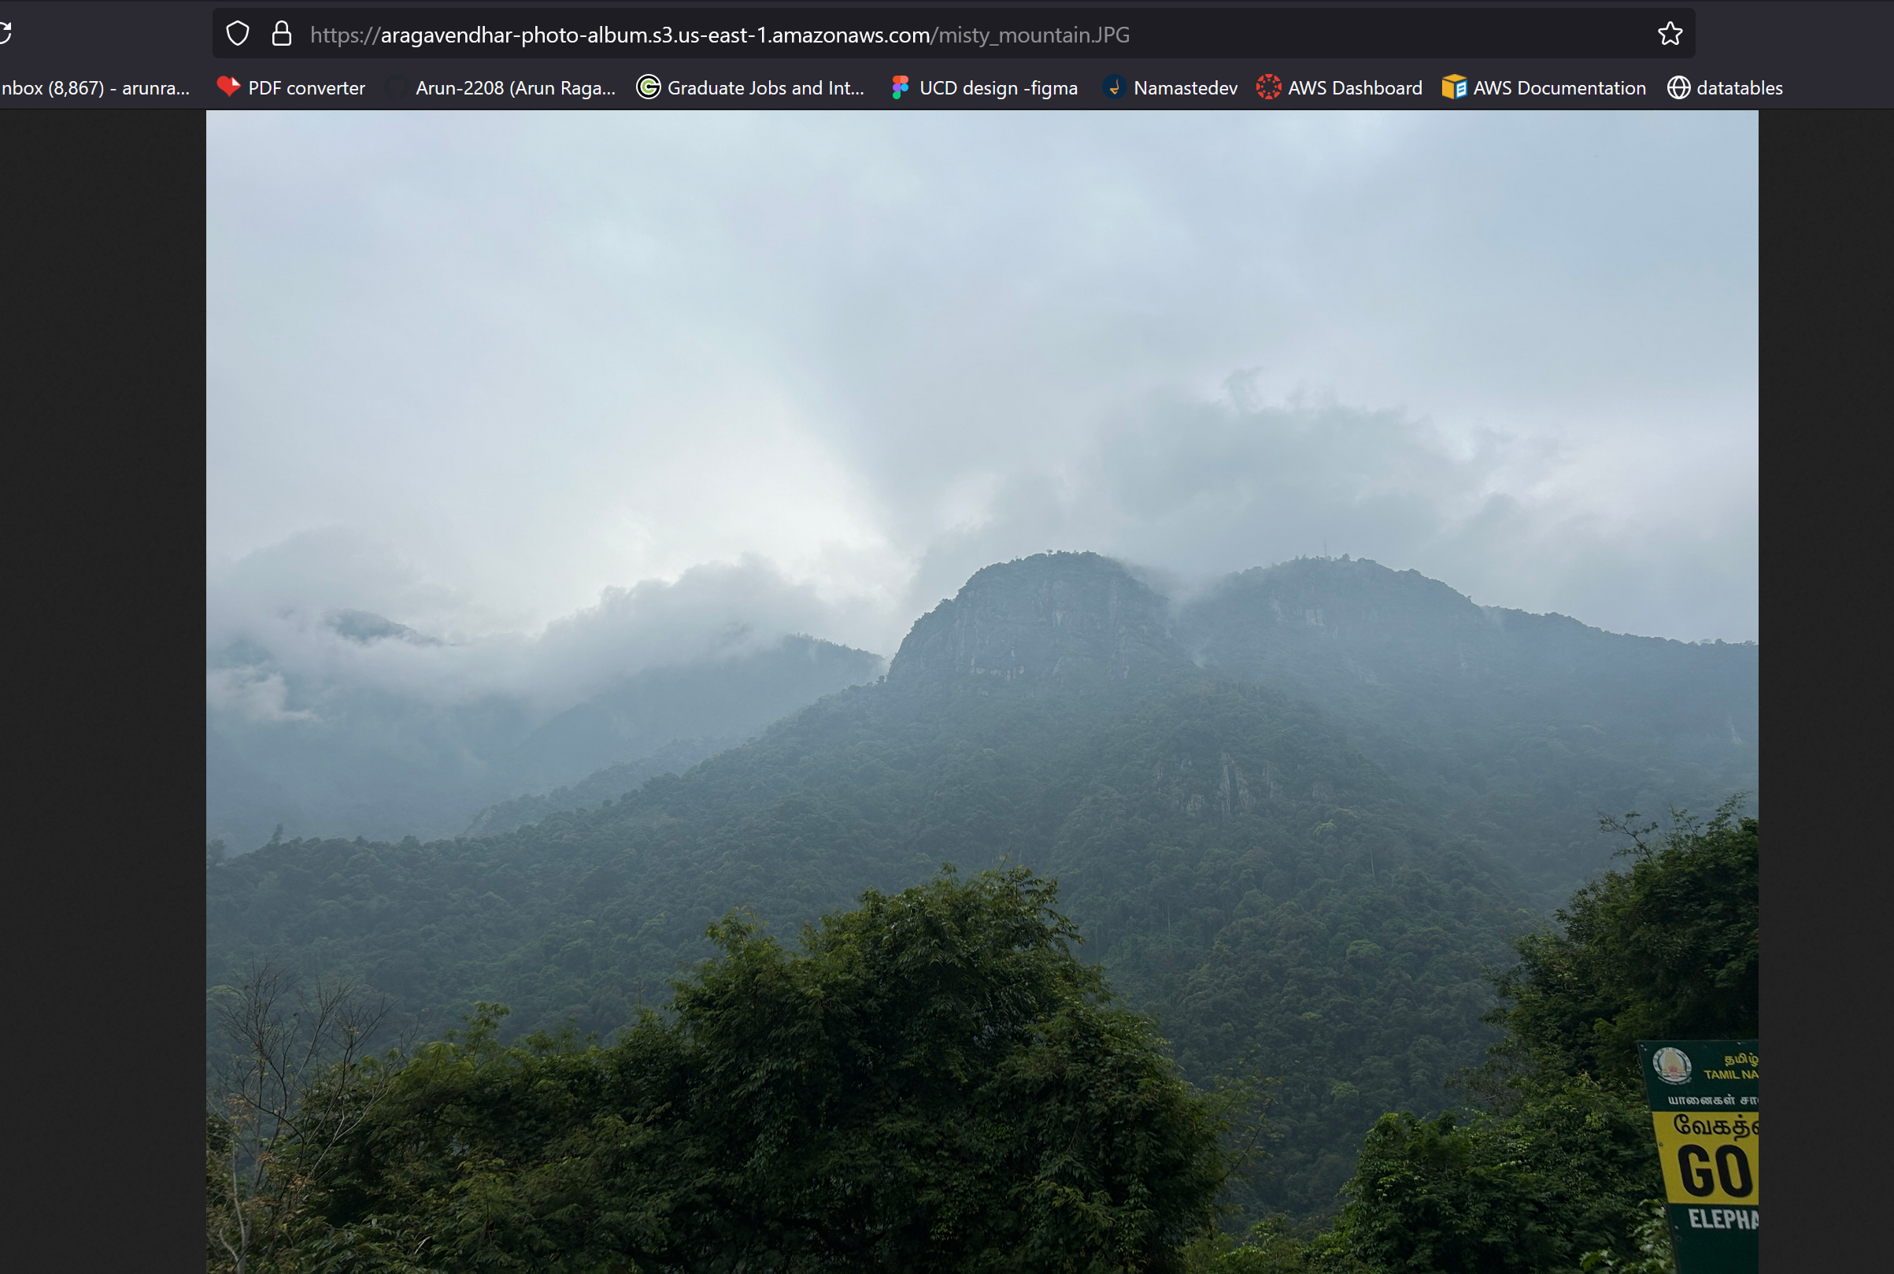

{

"Version": "2012-10-17",

"Statement": [

{

"Sid": "PublicReadGetObject",

"Effect": "Allow",

"Principal": "*",

"Action": "s3:GetObject",

"Resource": "arn:aws:s3:::aragavendhar-photo-album/*"

}

]

}

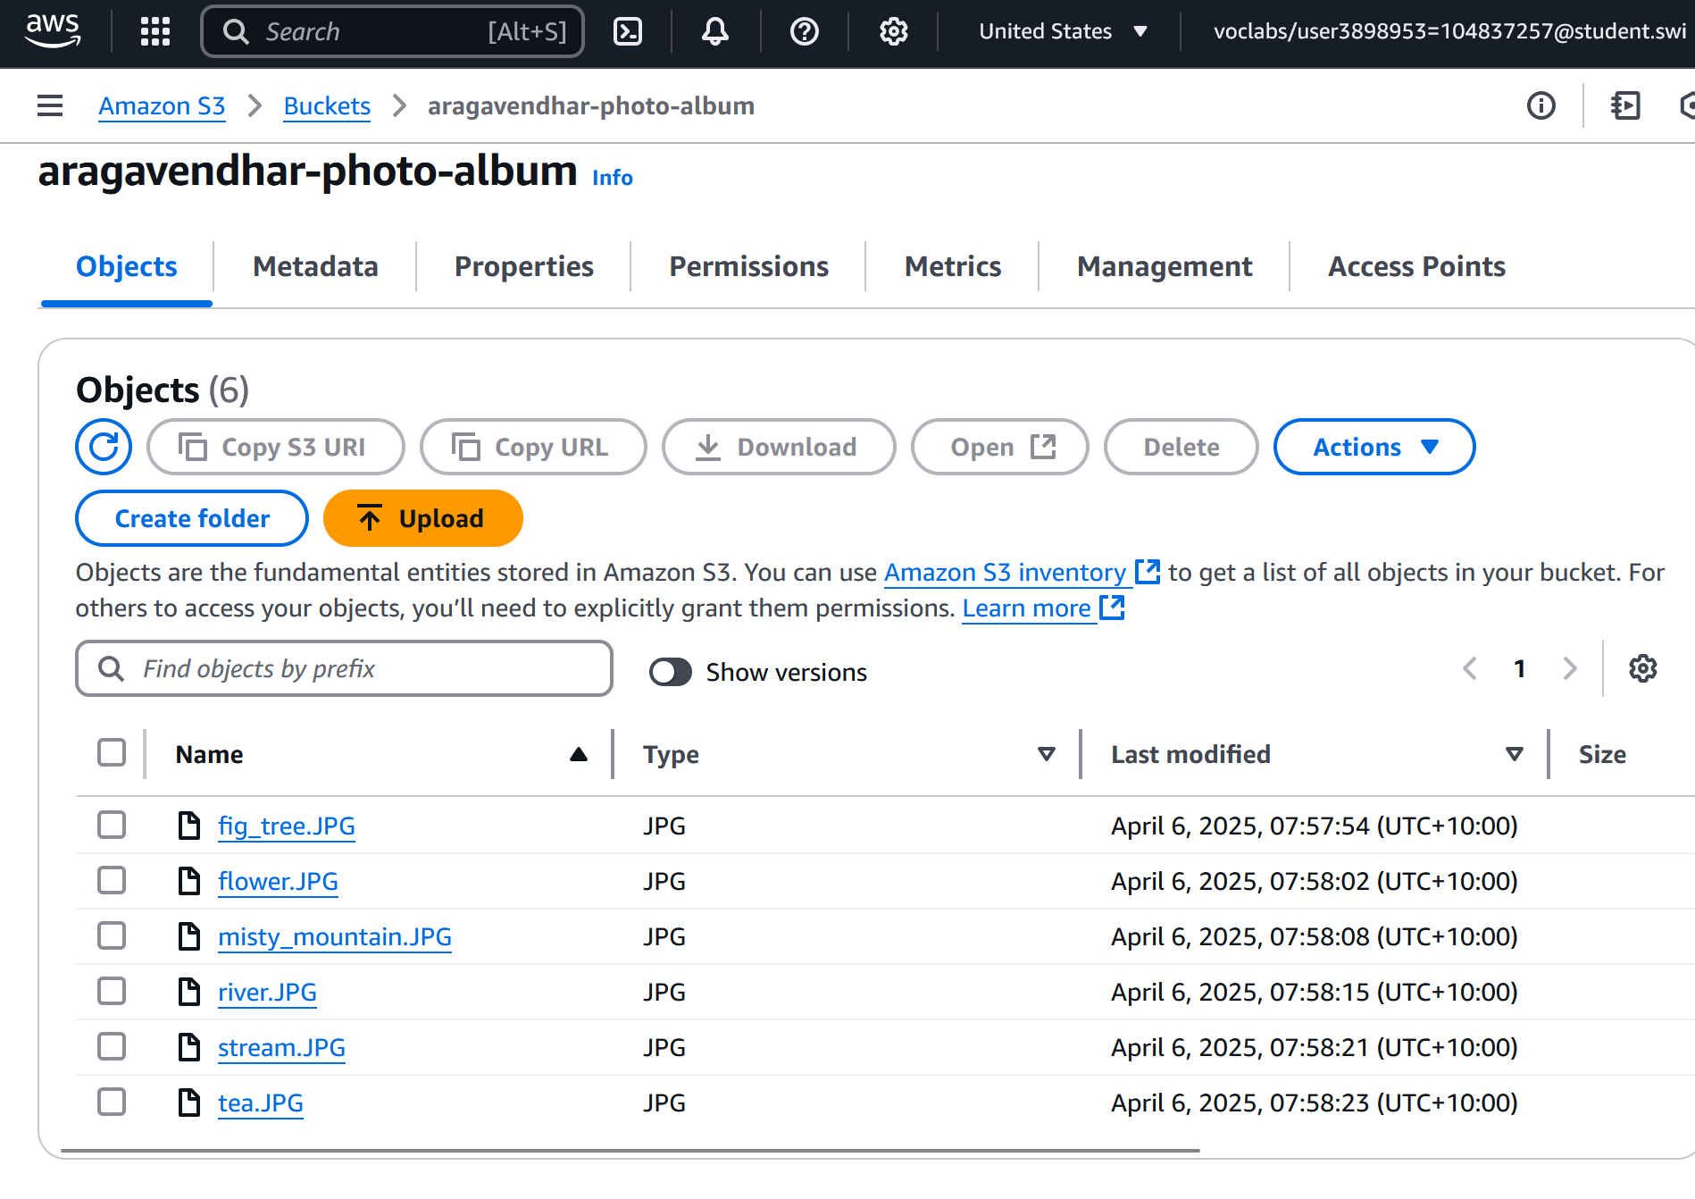

## 2.2 Photo meta-Data storage in RDS DB

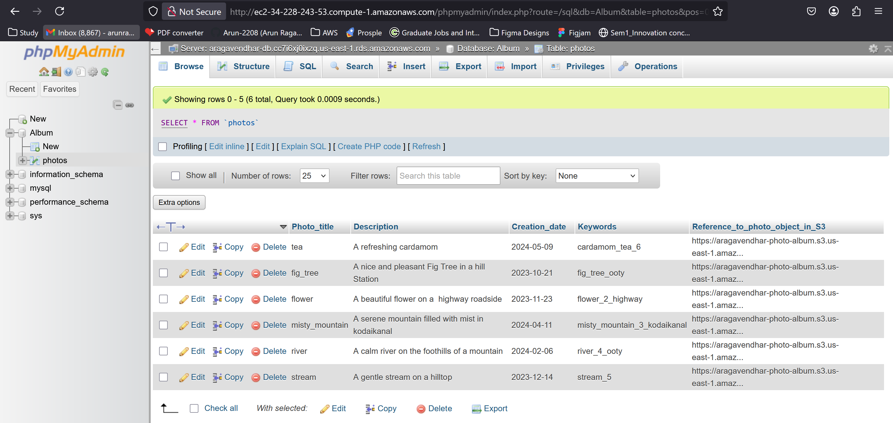

## 2.3 Photo Album website Functionality

The provided code photoalbum_v3.0 was uploaded to the /var/www/html/cos80001/photoalbum/ directory on the web server.

In the constants.php file, I updated the database connection details and the names of the fields so that they matched what was created in the RDS database.

The album could then be accessed at:

http://ec2-34-228-243-53.compute-1.amazonaws.com/cos80001/photoalbum/album.php

On this page, all the photos uploaded to S3 appeared along with their metadata from RDS. Search and filtering features also worked as expected.

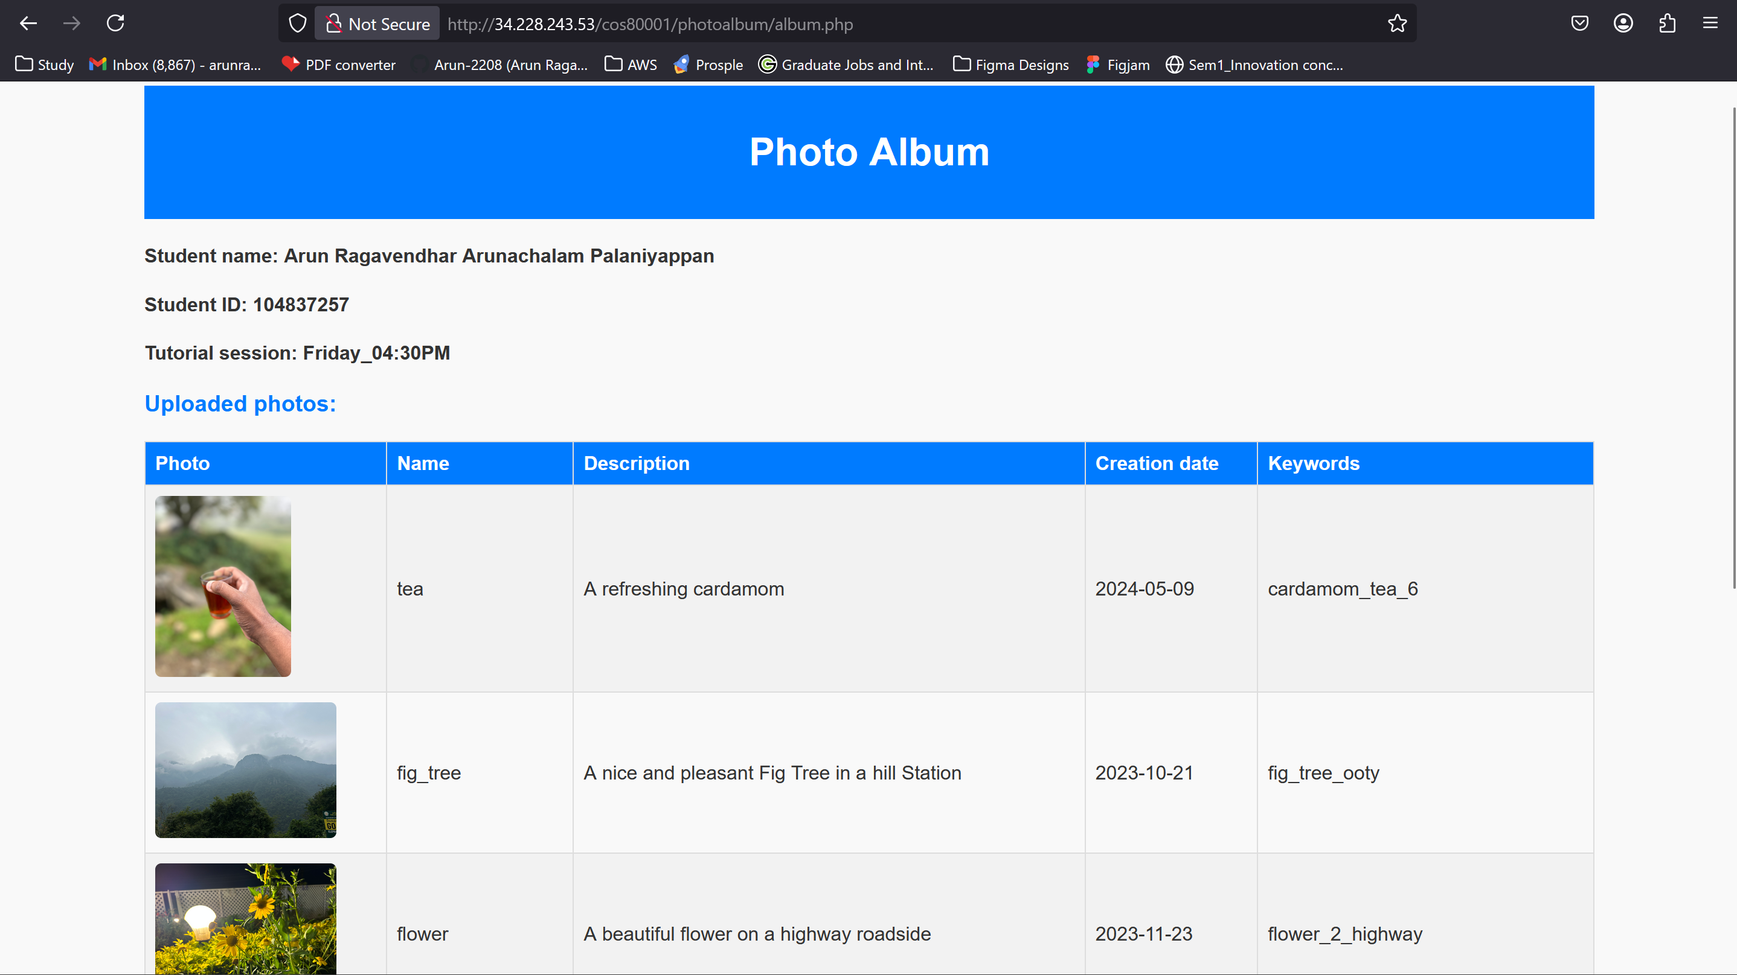

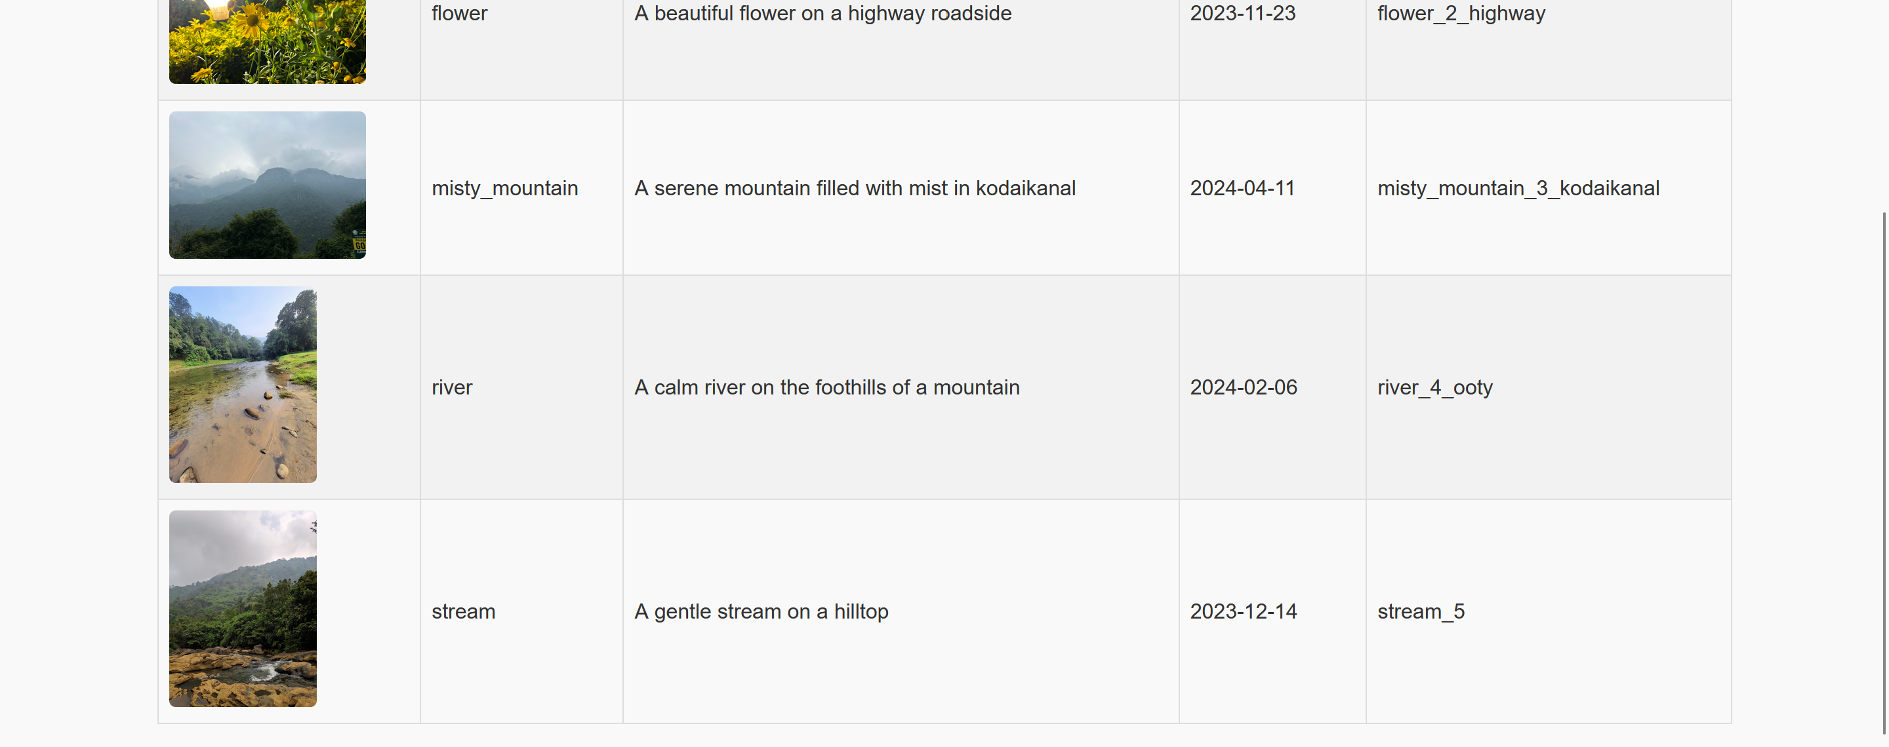

## 7. Testing and Verification

* The Test instance (private subnet) was accessed via SSH from the bastion host.
* A ping test to the web server confirmed that ICMP was working.
* Screenshots of database entries and web album display were captured.
* Access to the site through the Elastic IP confirmed that the website worked even after rebooting the instance.

## 8. Challenges Faced

* Initially, the database couldn’t be accessed. This was fixed by correctly linking the private subnet and applying the right security group rules.
* phpMyAdmin required Apache configuration changes. After installing necessary PHP modules, it worked smoothly.
* The Network ACL blocked HTTP access at first. After adjusting the rules to allow inbound HTTP from 0.0.0.0/0 and ICMP from the test subnet, everything worked.

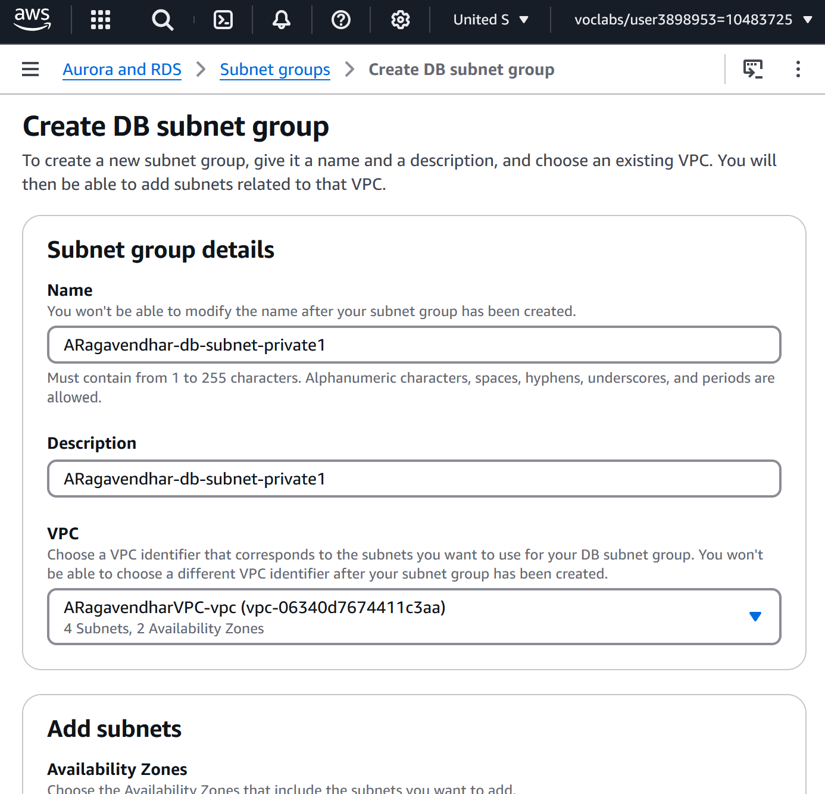 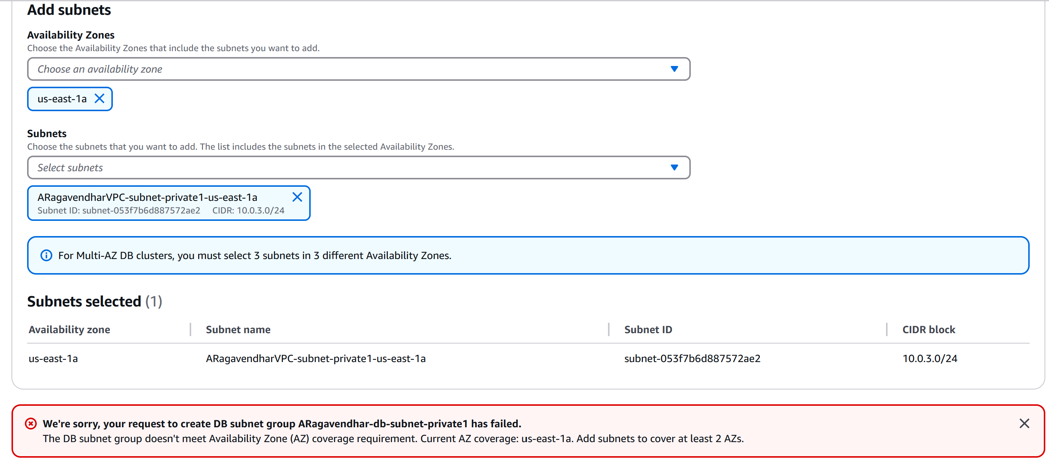

## 9. Conclusion

This assignment helped me understand how cloud infrastructure components work together. From secure network setup to deploying a dynamic website, each part needed careful planning. Using VPC, EC2, RDS, S3, and IAM, I was able to build a working photo album system that is both secure and functional.

## 10. Appendix

* Website link: http://ec2-34-228-243-53.compute-1.amazonaws.com/cos80001/photoalbum/album.php